**Use Case Diagram**

Actors vs Use Cases:

**Actor 1:User**

•Register.

•Recharge.

•Select Payment Gateway.

•Select service Provider.

•Make payment.

**Actor 2:Third Party Administrator**

•Forward User request to Service Provider.

•Track Complaints.

**Actor 3:Third Party Server/ Database**

•Authenticate the Registered users.

•Maintain the Log.

**Actor 4:Service Provider**

•Recharge the user requested either directly or through the third party system.

•Provide various plans to the user.

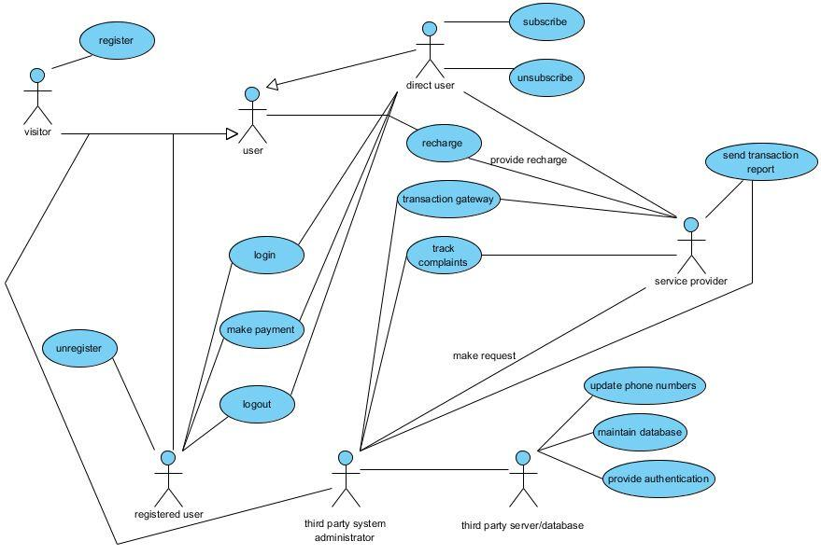

**Activity Diagram For Online Recharge System**

Activities Delt in the System:

User login and authentication for Registered user.

Forward the request to service provider if logged in as a Administrator.

Enter service provider site for a direct user.

Enter recharge amount.

Select Payment Gateway.

Login and authenticate Bank Account.

Make payment.

Check for the recharge processed successfully or not.

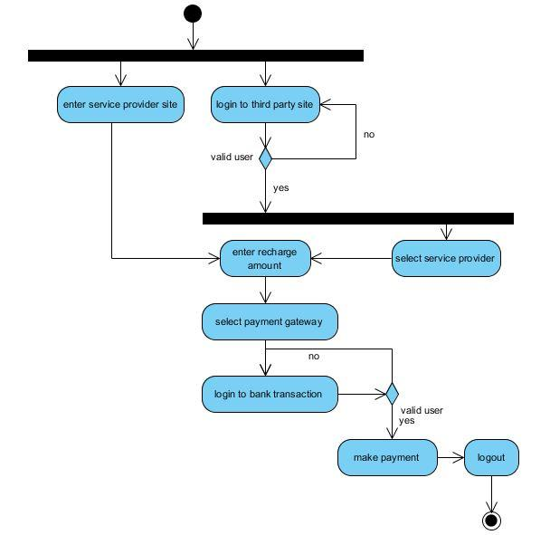

**State Diagram**

**States:**

Authentication for registered users / Registration for unregistered users

Successfully logged on or re-login

Operator Selection

Show the tariff plans available and applicable

Request recharge

Go through Payment Gateway Transaction process

•Authentication to enter the gateway site

•Successfully logged on or re-login

•Payment made

Logged off.

**Transitions:**

Registration ---> Authenticate ---> Logged in

Logged in ---> Operator Selection ---> Tariff Plans <---> Request Recharge

Operator Selection ---> Request Recharge ---> Payment Gateway Transaction

Payment Gateway Transaction ---> Operator Selection

Payment Gateway Transaction ---> Logged off

